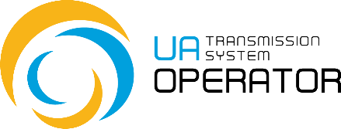
APPLICATION
for allocation EIC code of a Party (market participant) within IEM (Energy Internal European Market)
Details of the Party (market participant):
EIC code allocated by LIO LLC Gas TSO of Ukraine *
Short name* (maximum 16 symbols)
Full name* (maximum 70 symbols)
EIC Parent
EIC Responsible Party
Country
Postal Code
City
Address
VAT Code*

Contact Details of the Party (market participant):
Contact Person for EIC Matters*
Telephone*
Email*
*Mandatory fields

Function of the Party (market participant):
Choose only one option

Trade Responsible Party (Trader)
Production Responsible Party (Producer)
Network user
Direct Consumer
Distribution System Operator
Storage System Operator
LNG System Operator

The LIO LLC Gas TSO of Ukraine checks the submitted application, integrates the EIC code into the Central Repository and publishes it on a weekly basis.
EIC codes and EIC Reference Manual can be found under http://www.eiccodes.eu.

By signing this application the Party agrees for transfer of the information therein to a third party for administrative purposes. LLC Gas TSO of Ukraine will not use any personal data of the Party for any marketing or sales activities.

______________________________________  signature of the authorized person, stamp | __________________  place and date

