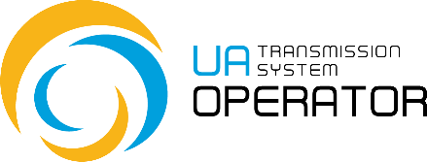

Manual of using Information Platform
Non-binding demand indications for incremental capacity

Version 2.0
26.04.2023

Consultations

E-mail: | Iplatforma @tsoua.com
Contact phone: | (044) 298-64-64

Non-binding demand indications for incremental capacity

Transaction functionality: The transaction collects completed non-binding demand indications for incremental capacity at interconnection points.
Pay attention: -
Entry to transaction: The process of maintaining non-binding demand indications for incremental capacity is performed by means of the menu item “Optional requests for new capacity” (Indications for incremental capacity). To go, just double-click on the selected line in the menu item.
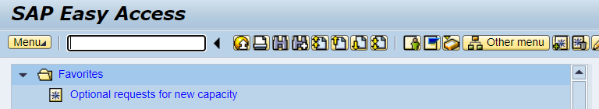

According to the requirements of the Gas Transmission System Code, the procedure for assessing the market demand for incremental capacity in 2021 should begin on 3 July 2023 Kyiv time (together with the start of annual firm capacity auctions) and last for 8 weeks (27 August 2023 inclusive). Accordingly, access to the above transaction is provided from 00:00 3 July 2023 (Kyiv time) to 00:00 28 August 2023 (Kyiv time) to all registered network users, without exception, for the possibility of transferring filled non-binding demand indications for incremental capacity to LLC "Gas TSO of Ukraine".

The first screen shows the year of submission of indications (current year) and an EIC code of a network user:
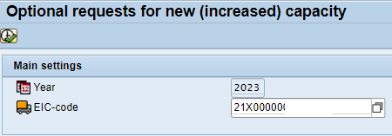

Click 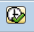 and go to the interface of the register of indications:

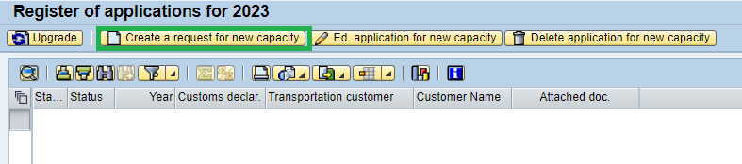

To create an indication, click , then "Save” and attach the document in pdf/docx format.

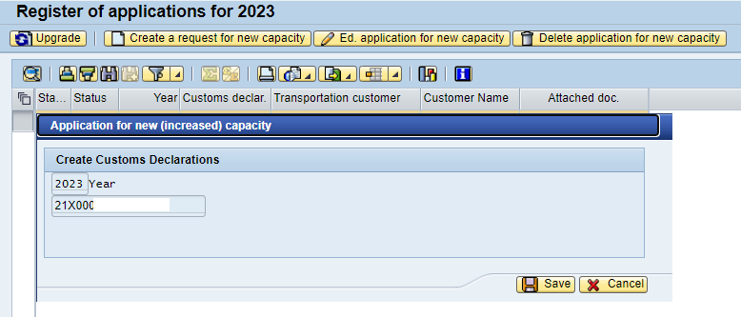

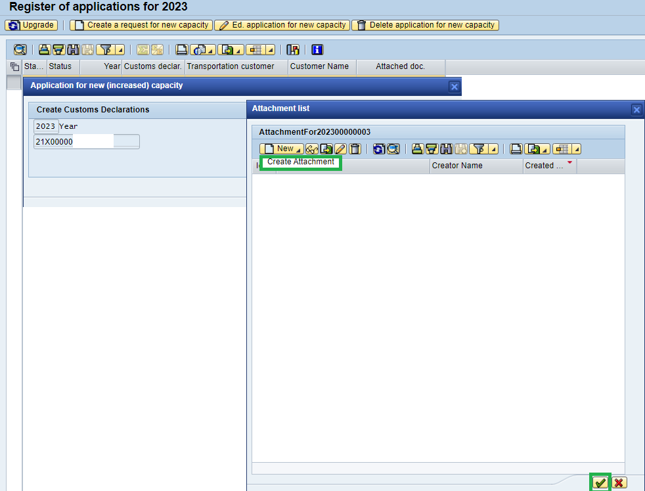

Add attachments.
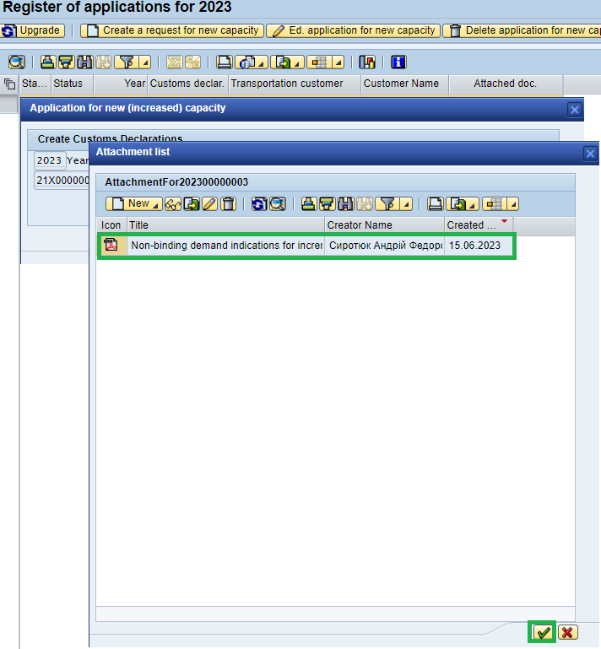

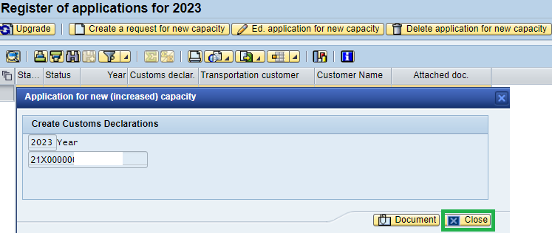

Checking of the file attached by clicking button, then button
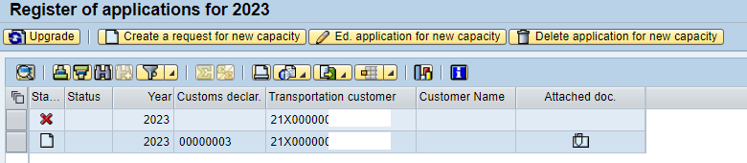

New indication will be displayed in the report on the screen «Register of applications for 2023
You can review the attachment by selecting the icon :

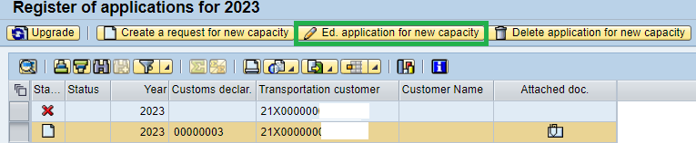
Editing the indication is possible on the button , it is possible to change the attachment, add another document, changes are fixed by electronic digital signature.
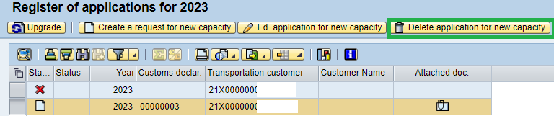

Deleting the indication is possible with the button:.

