Calculation of the term of the bank guarantee
Code norm | Example
Gas (reporting) month of services provision | November 2021
Until the 14th calendar day of gas month after the reporting month, sends to the Network User the invoice for the daily imbalance  (Chapter 6 Section XIV of the GTS Code) | Until December 14, 2021
Network User has to pay for the daily imbalance until the 20th calendar day of the month following the reporting month  (Chapter 6 Section XIV of the GTS Code)  If the last day of the term falls on a day off, holiday or other non-working day determined in accordance with the law in the place of commission of a certain action, the day of expiration of the term is the first working day after it.  (p. 5 of Article 254 of the CC) | Until December 20, 2021
The validity of the financial security must end no earlier than 5 business days after the period of payment for the performance of actions for the settlement of daily imbalance,  (Chapter 2 Section VIII of the GTS Code) | The bank guarantee must be valid at least until December 29, 2021

In order for the bank guarantee to be financial security for the month of transportation November 2021, it must be valid at least until December 29, 2021
December 2021
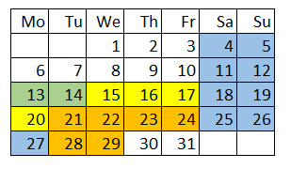
- weekends and holidays
- sending an invoice for an imbalance
- imbalance payment
- no earlier than 5 working days after payment of the imbalance

